

**Data Technician**

|  |
| --- |
|  |

|  |
| --- |
| Name: |
| Course Date: |
|  |

**Table of contents**

Day 1: Task 1 3

Day 1: Task 2 3

Day 3: Task 1 4

Day 4: Task 1: Written 6

Day 4: Task 2: SQL Practical 9

Course Notes 19

Additional Information 19

# Day 1: Task 1

Please research and complete the below questions relating to key concepts of databases.

|  |  |
| --- | --- |
| What is a primary key? | A primary key is column or set of columns in a table that uniquely identifies each row or record. It ensures every entity is distinct and prevents duplicate or null value which helps maintain data integrity. |
| How does this differ from a secondary key? | It is a key which is an alternate key that uniquely identifies a record but not a primary key. They are used to speed up searches and queries on fields other than the primary key. |
| How are primary and foreign keys related? | They are both unique identifiers in a recorded table where a foreign key references the primary key of another table creating links between the two |
| Provide a real-world example of a one-to-one relationship | A Husband and Wife or Mother and Daughter |
| Provide a real-world example of a one-to-many relationship | A mother and her children or a School and all of its pupils |
| Provide a real-world example of a many-to-many relationship | An actor and film or a Recipe and an Ingredient |

# Day 1: Task 2

Please research and complete the below questions relating to key concepts of databases.

|  |  |
| --- | --- |
| What is the difference between a relational and non-relational database? | A relational database stores data in rows and columns, like a spreadsheet, with clear links between tables. A non-relational database stores data in more flexible formats such as documents or key-value pairs and doesn’t rely on a strict table structure. Relational databases are best for structured data that doesn’t change often, while non-relational ones are better for unstructured, changing, or diverse data. |
| What type of data would benefit off the non-relational model?  Why? | Non‑relational (NoSQL) databases work best for messy, flexible data like social media posts, user profiles, logs, or product catalogues where each record can have different information. They’re great when data is unstructured or always changing, because you don’t need to force it into rigid tables or a fixed format. This model also suits real‑time feeds, sensor data, or anything that grows fast and needs to scale easily across lots of servers for speed and storage |

# DAY 2 SCREENSHOTS:

# A screenshot of a computer screen AI-generated content may be incorrect.AND

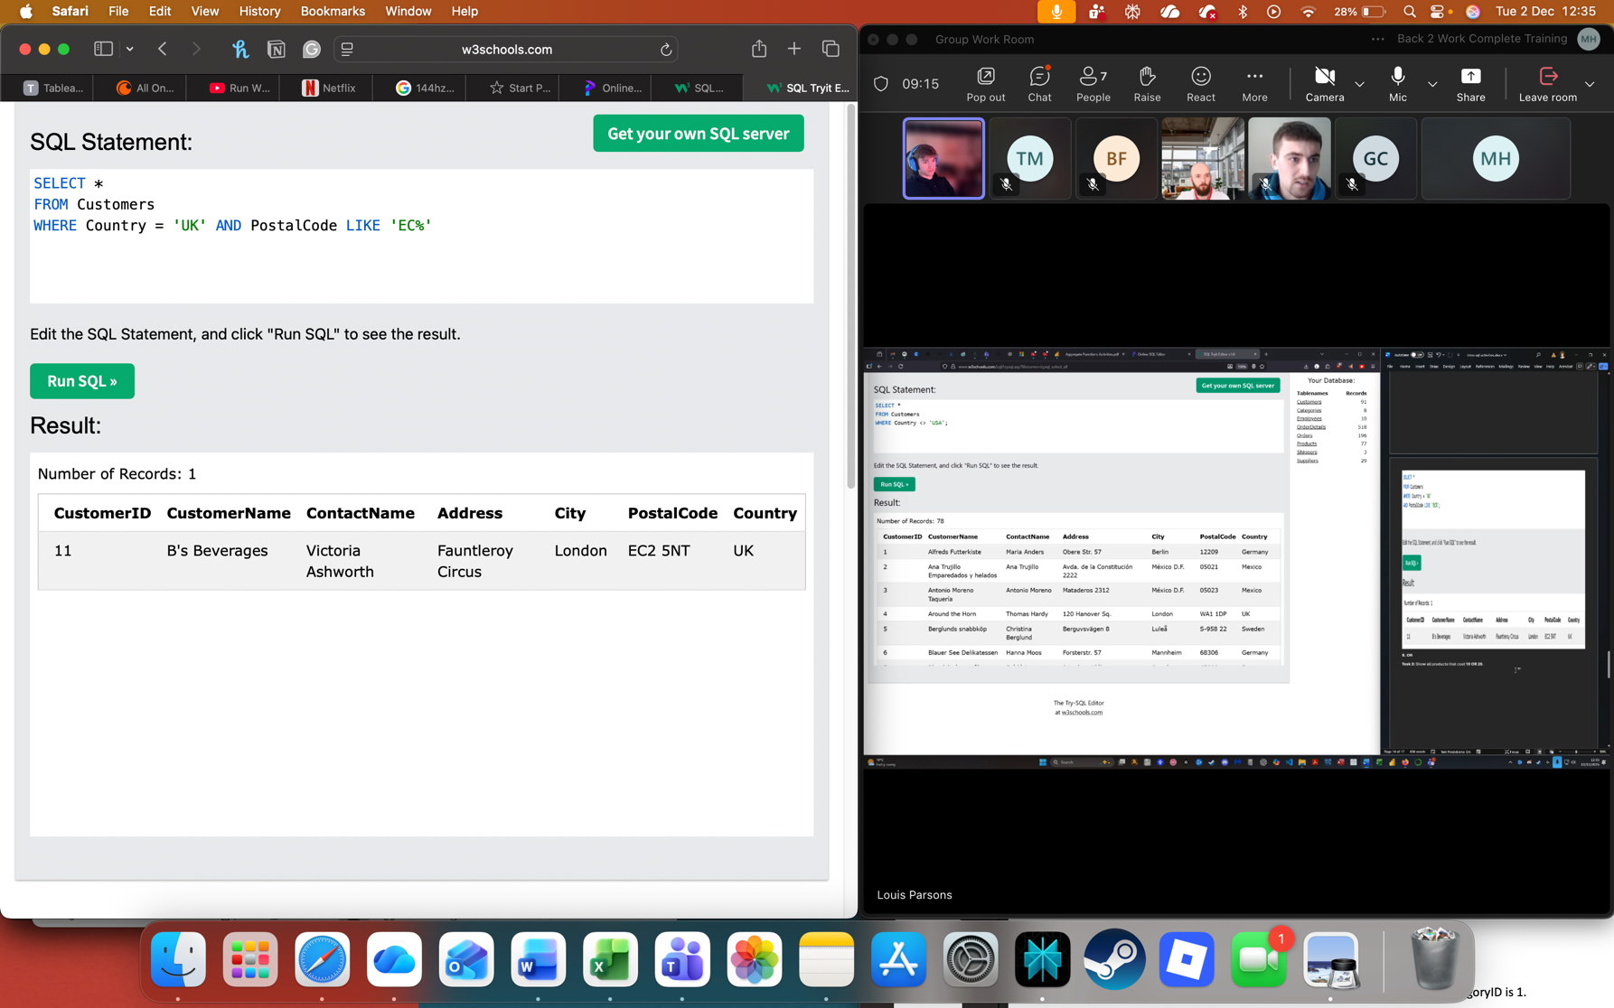AND

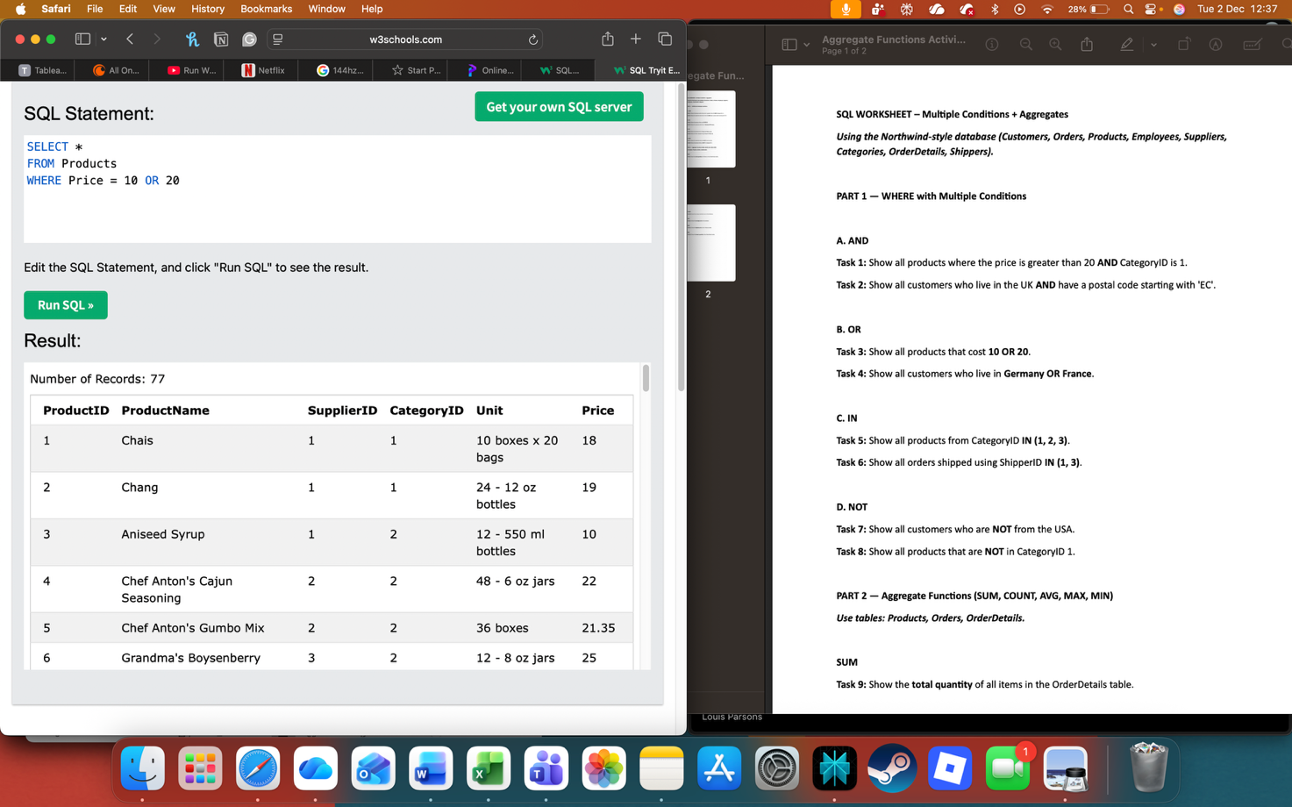 OR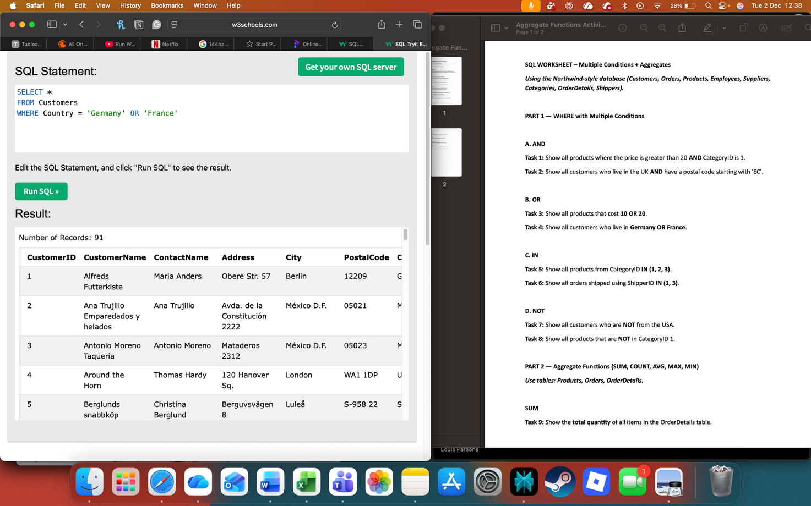 OR

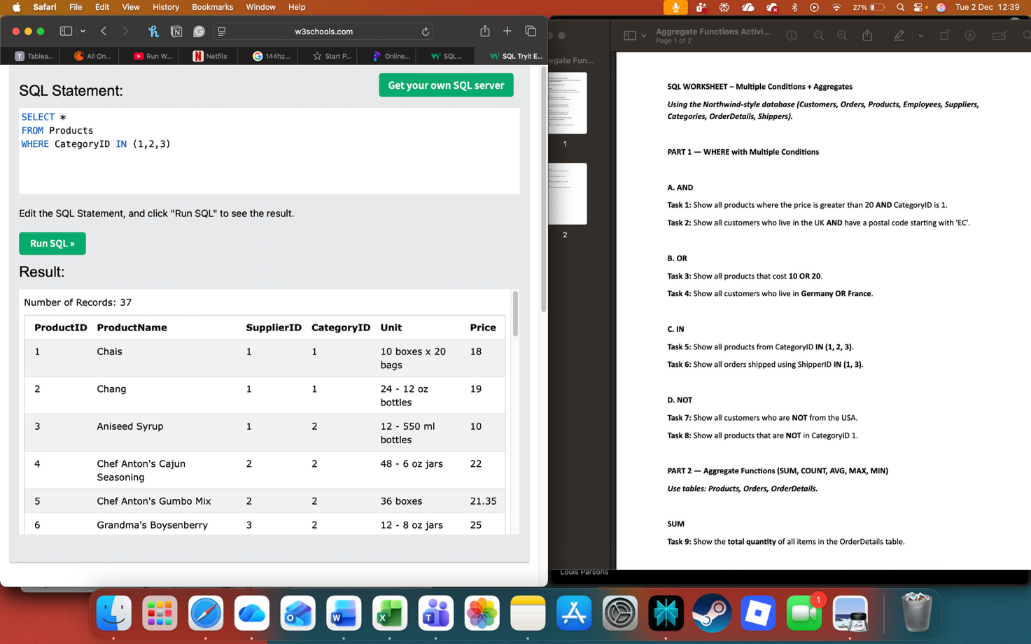WHERE IN

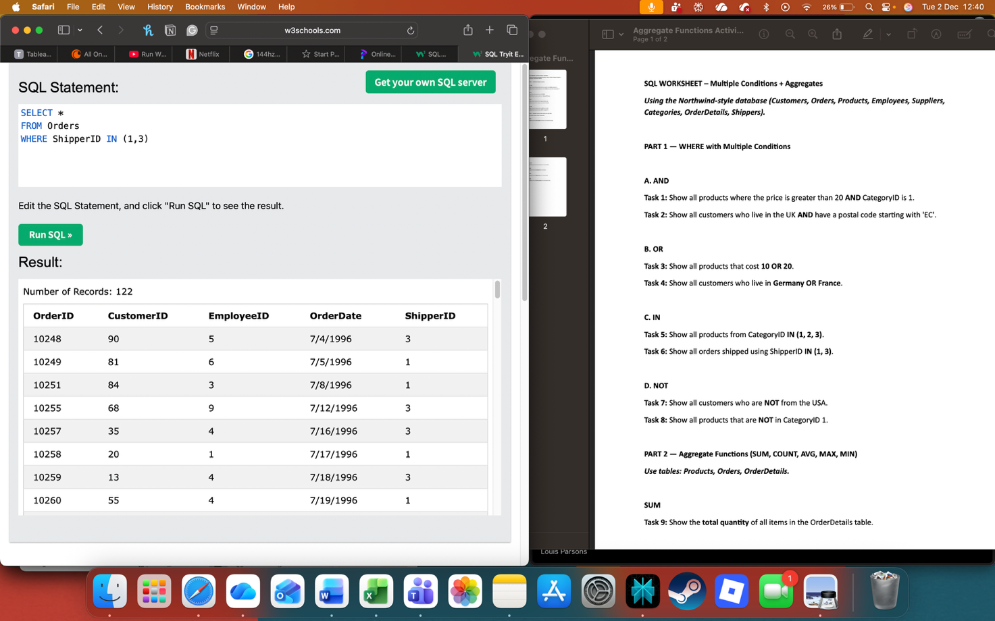WHERE IN

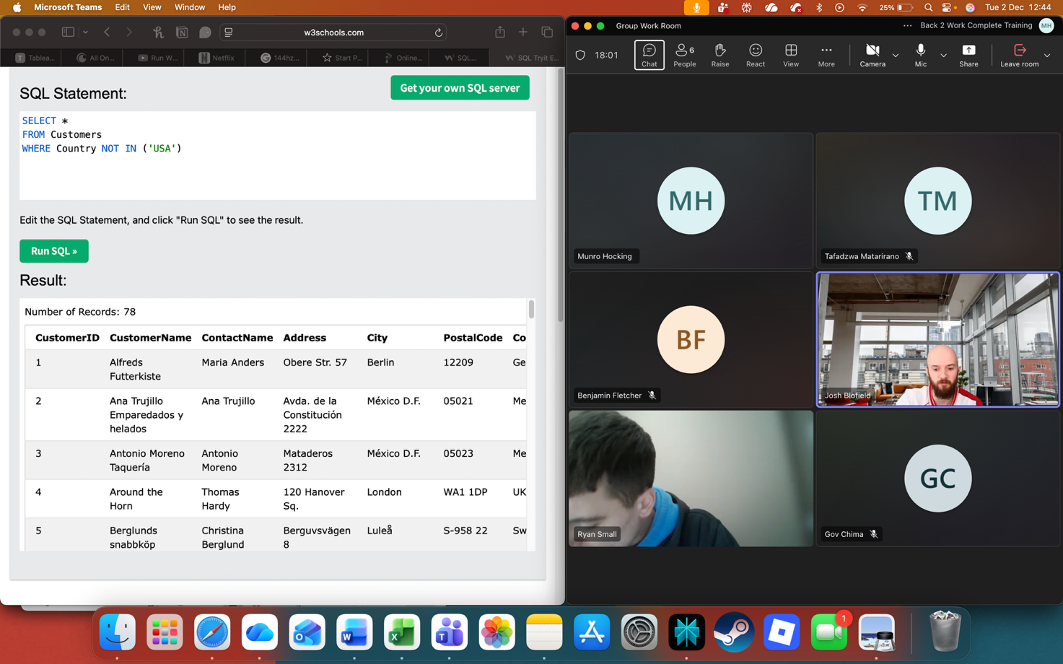WHERE NOT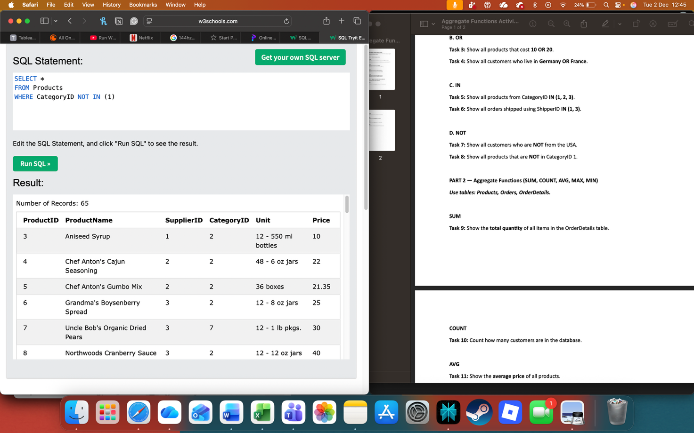 WHERE NOT

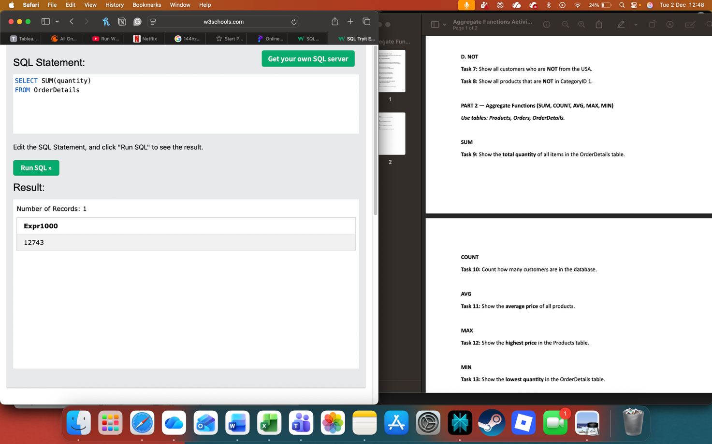SUM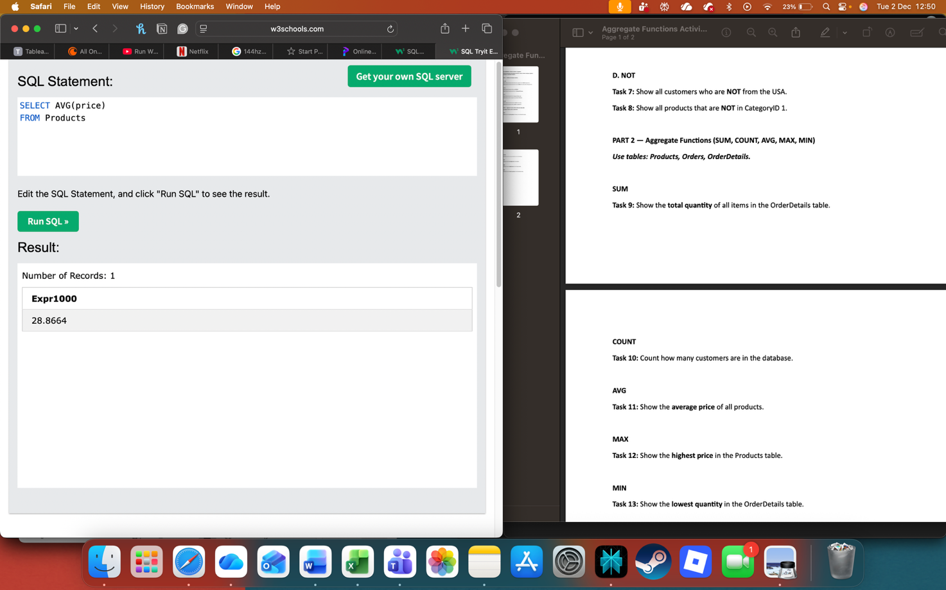AVG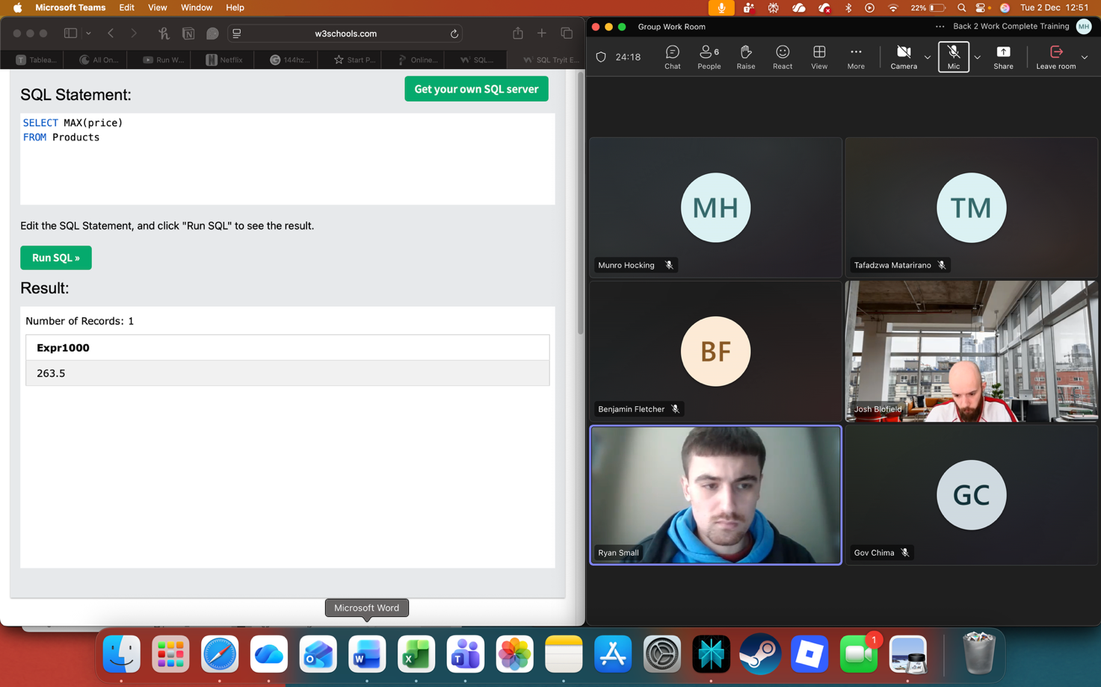MAX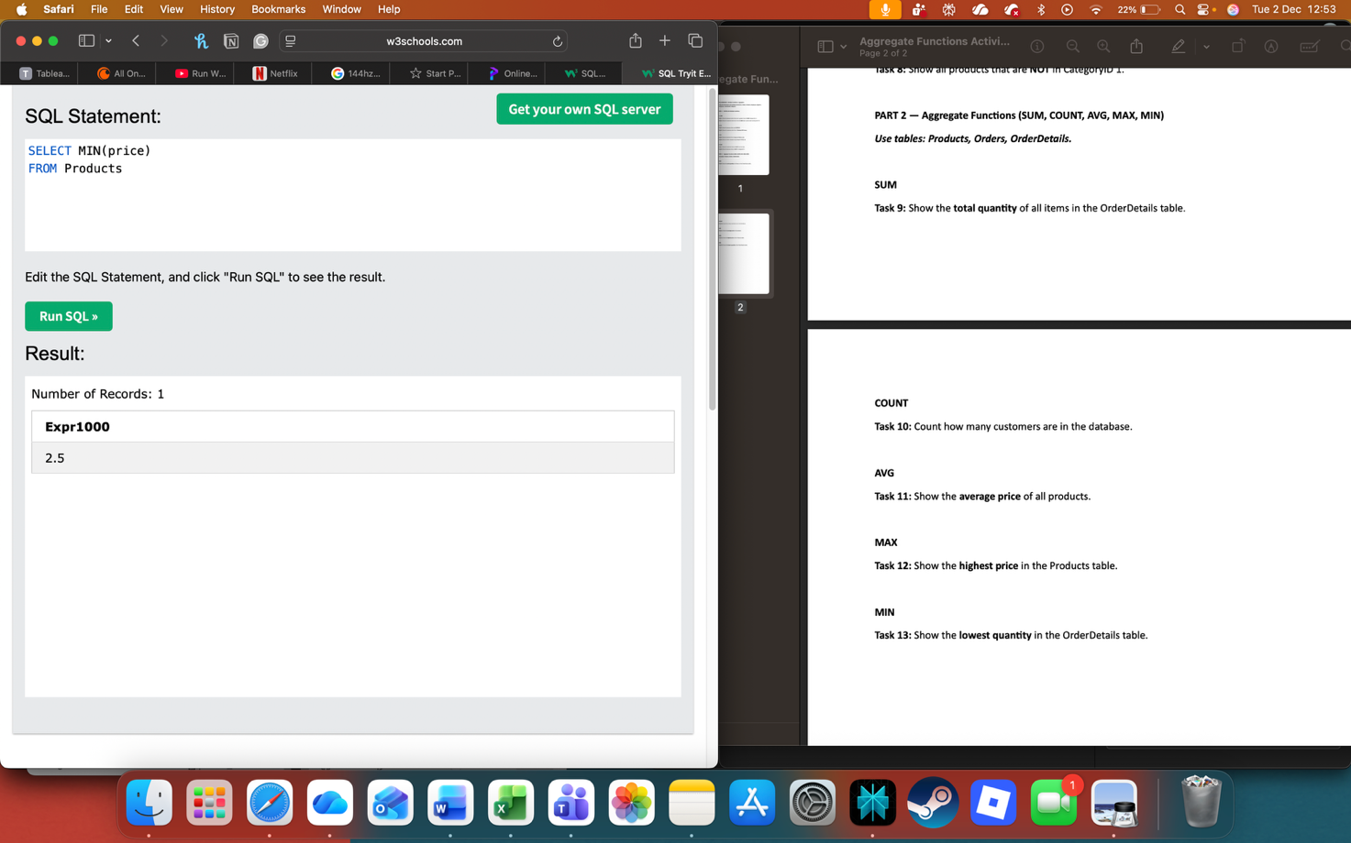MIN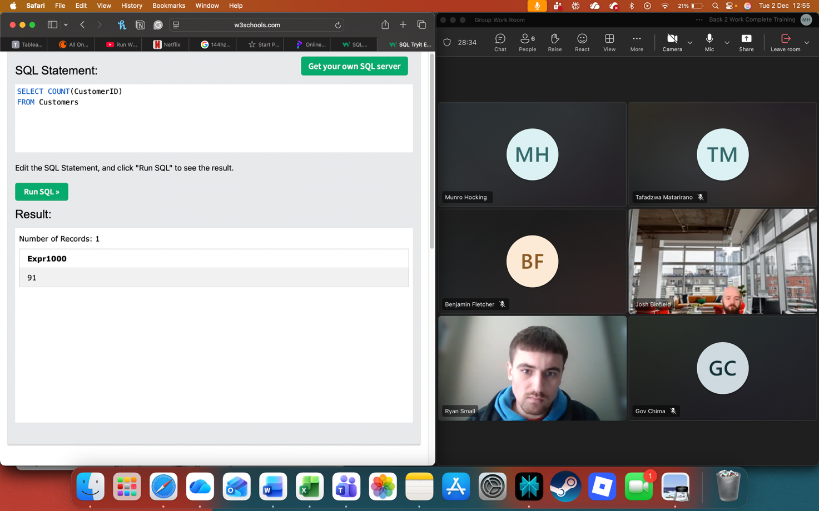COUNT

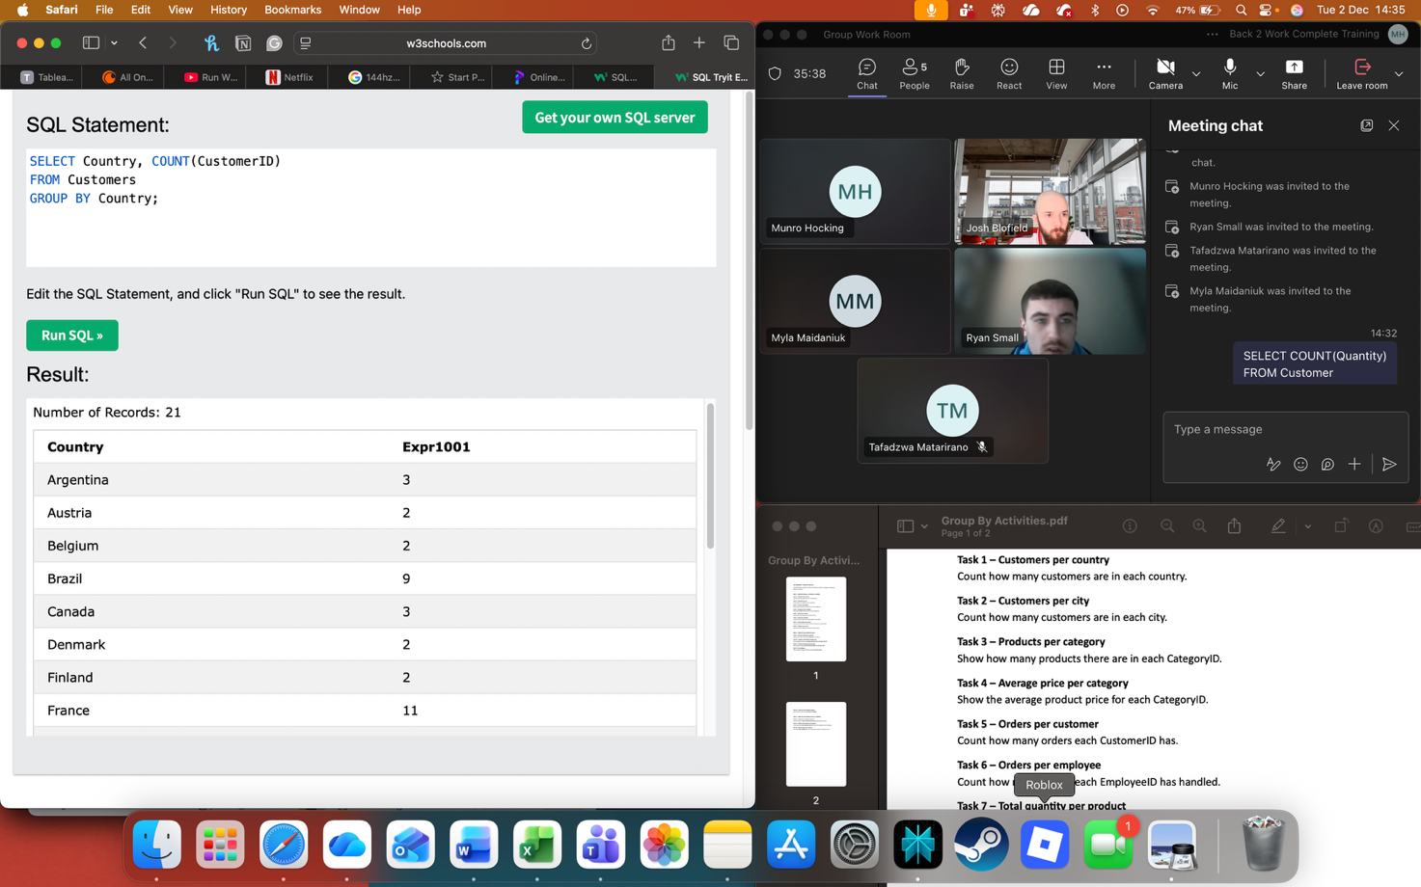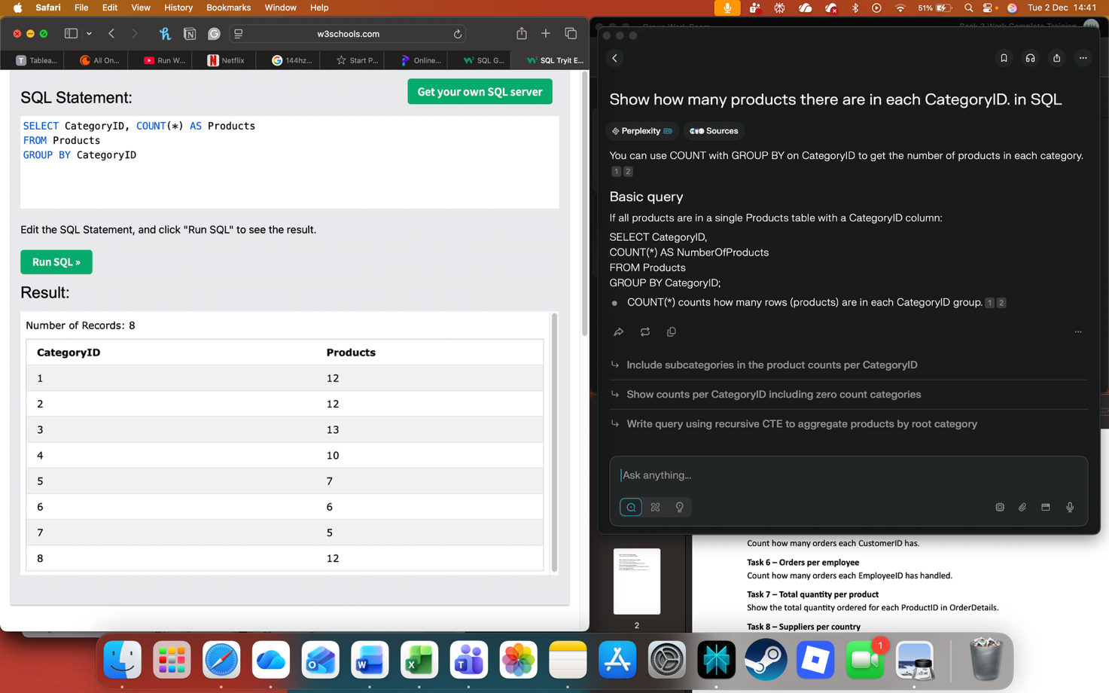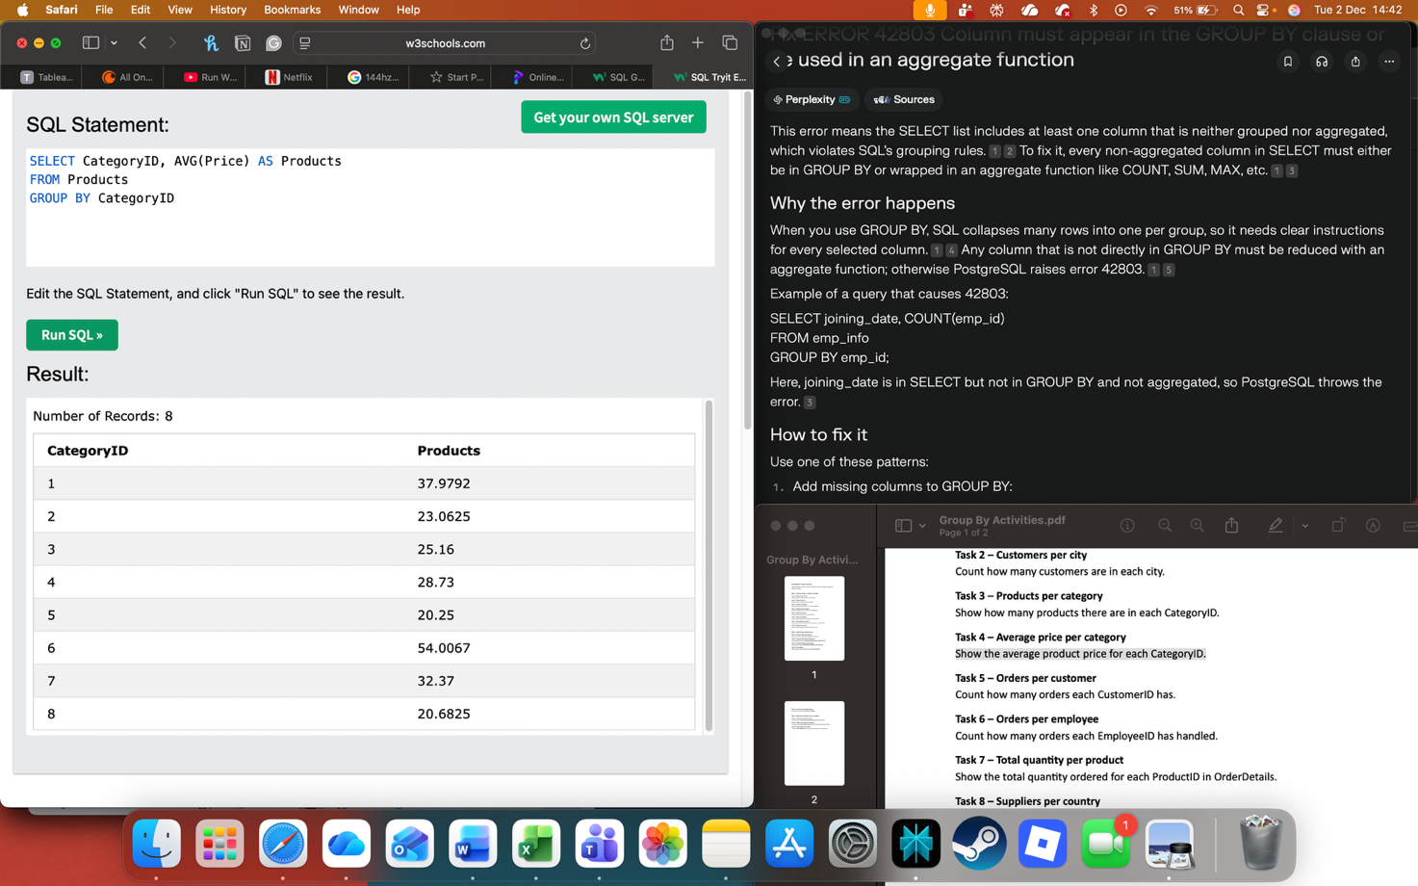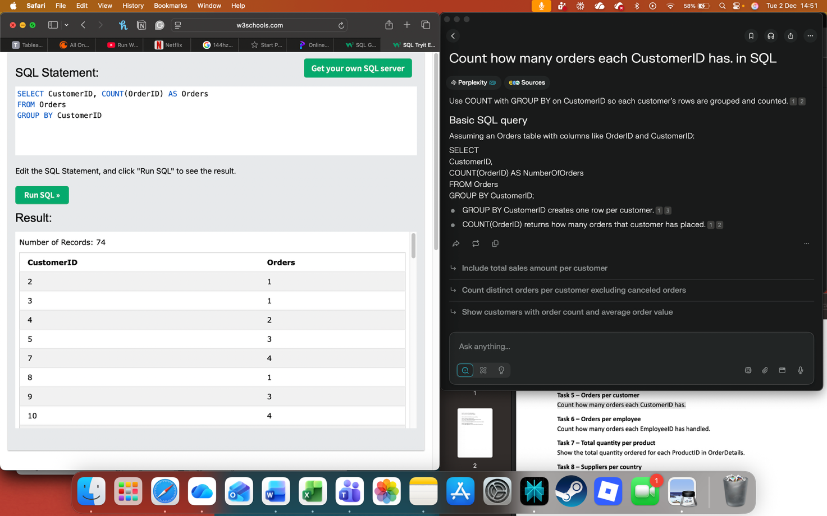

# Day 3: Task 1

Please research the below ‘JOIN’ types, explain what they are and provide an example of the types of data it would be used on.

|  |  |
| --- | --- |
| Self-join | A self-join is a query where a table is joined to itself so you can compare or relate rows within that same table.  A common type of data for a self-join is hierarchical or parent-child data, such as an employee’s table that has a ManagerID column pointing to another row in the same |
| Right join | A RIGHT JOIN returns all rows from the right-hand table in the join, plus any matching rows from the left-hand table; where there is no match, the left table’s columns come out as NULL.  For a self-join with a RIGHT JOIN, you still join a table to itself, but you keep all rows from the “right” alias; for example, on an Employees table you might use a RIGHT self-join to show every employee and, where available, their subordinate or related row, even when some employees have no corresponding match on the “left” side. |
| Full join | Self-join with INNER JOIN shows only matching rows within the table (e.g., employees with managers).  Self-join with RIGHT JOIN includes all rows from the right alias, plus matches from left (e.g., all potential managers, even without employees).  Self-join with FULL JOIN includes all rows from both aliases, filling non-matches with NULLs (e.g., every employee and manager relation, bidirectional). |
| Inner join | An INNER JOIN returns only the rows with matching values in both tables being joined. In a self-join scenario, it means joining a table to itself and retrieving rows where the join condition matches on both sides. For example, in an Employees table, an INNER self-join can pair each employee with their manager by matching employee.manager_id to manager.employee_id. This shows only employees who have a matching manager |
| Cross join | A CROSS JOIN returns the Cartesian product of two tables, meaning it pairs every row from the first table with every row from the second table. In a self-join context, a CROSS JOIN on the same table pairs every row with every other row, creating all possible combinations of rows within that table. This join does not use any condition to filter rows.  For example, if a table has employees A, B, and C, a self CROSS JOIN would generate pairs AA, AB, AC, BA, BB, BC, CA, CB, and CC. This is useful when you want to analyse all possible pairings or combinations from the table. |
| Left join | A LEFT JOIN in a self-join context returns all rows from the left side (the first alias of the table) and the matching rows from the right side (the second alias). If there is no match on the right, the result includes NULLs for that side’s columns. For example, in an Employees table, a LEFT self-join can show every employee along with their manager if they have one; employees without managers still appear with NULLs for the manager data. |

# Day 4: Task 1: Written

In your groups, discuss and complete the below activity. You can either nominate one writer or split the elements between you. Everyone however must have the completed work below:

*Imagine you have been hired by a small retail business that wants to streamline its operations by creating a new database system. This database will be used to manage inventory, sales, and customer information. The business is a small corner shop that sells a range of groceries and domestic products. It might help to picture your local convenience store and think of what they sell. They also have a loyalty program, which you will need to consider when deciding what tables to create.*

*Write a 500-word essay explaining the steps you would take to set up and create this database. Your essay should cover the following points:*

1. ***Understanding the Business Requirements****:*
   1. *What kind of data will the database need to store?*
   2. *Who will be the users of the database, and what will they need to accomplish?*
2. ***Designing the Database Schema****:*
   1. *How would you structure the database tables to efficiently store inventory, sales, and customer information?*
   2. *What relationships between tables are necessary (e.g., how sales relate to inventory and customers)?*
3. ***Implementing the Database****:*
   1. *What SQL commands would you use to create the database and its tables?*
   2. *Provide examples of SQL statements for creating tables and defining relationships between them.*
4. ***Populating the Database****:*
   1. *How would you input initial data into the database? Give examples of SQL INSERT statements.*
5. ***Maintaining the Database****:*
   1. *What measures would you take to ensure the database remains accurate and up to date?*
   2. *How would you handle backups and data security?*

*Your essay should include specific examples of SQL commands and explain why each step is necessary for creating a functional and efficient database for the retail business.*

|  |  |
| --- | --- |
| Please write your 500-word essay here | Designing a database for the small corner shop begins with clearly defining the business requirements. The shop sells everyday groceries such as milk, bread, and detergent, so the database must store detailed inventory information, including product names, categories, prices, and stock levels (for example, milk at £1.50 with 10 units in stock and bread at £1.00 with 20 units).  It must also capture sales data such as the date of sale, which products were sold, and in what quantities, as well as customer details including email addresses and loyalty points balances (for example, Jane Doe with 50 loyalty points).  Key users include the shop manager, who needs to monitor stock and sales trends, shop staff, who record transactions and check loyalty points, and IT support, who maintain system performance.  Using these requirements, the next step is to design a schema that mirrors how the shop operates day to day. A Products table will hold core inventory attributes like Product ID, Product Name, Category, Price, and Stock Level, enabling clear tracking of items such as Milk (Dairy, £1.50, 10 units) and Bread (Bakery, £1.00, 20 units). A Customers table will store Customer ID, Name, Email, and Loyalty Points so the shop can recognise regular customers and reward them. The Sales table will link these two perspectives, with columns such as Sale ID, Product ID, Customer ID, Date, and Quantity, so that each sale (for example, 2 units of Milk sold to customer 1 on 2025‑01‑15) is associated both with the correct product and the correct customer. This structure creates clear relationships between products and sales, and between customers and sales, supporting stock updates and loyalty calculations  CREATE DATABASE  CornerShop;  CREATE TABLE Products (     ProductID INT PRIMARY KEY,     ProductName VARCHAR(100),     Category VARCHAR(50),     Price DECIMAL(10,2),     Inventory INT,     SupplierID INT,     FOREIGN KEY (SupplierID) REFERENCES Supplier(SupplierID));.  We have come up with this SYNTAX CODE to create tables within our database.  Design decisions must reflect these relationships before implementation. Each sale references a specific product so the system can reduce stock and calculate revenue accurately, ensuring that after selling 2 bottles of milk the stock level falls from 10 to 8. Similarly, linking customer records to sales allows the loyalty programme to accumulate points for every eligible transaction, using the stored Loyalty Points field to show current balances for customers like Jane Doe. This relational model supports many-to-one connections, with many sales rows pointing to a single product or customer, which is essential for later reporting on popular items or high‑value customers.  INSERT INTO Products (ProductID, ProductName, Category, Price, Inventory, SupplierID) VALUES (101, 'Apple Juice', 'Beverages', 2.49, 120, 1), (102, 'Wireless Mouse', 'Electronics', 15.99, 60, 2), (103, 'Vacuum Cleaner', 'Home Appliances', 89.99, 25, 3);  Here is an initial code on how we can INSERT the tables we created into our database  Although actual SQL is not the focus here, the design must anticipate how the system will be created and populated. The plan would be to use a database tool such as Microsoft Access or MySQL to create tables with the specified columns, then enter initial data like the core product list and existing loyalty customers using simple data entry forms or imports from spreadsheets. For example, staff might input Milk and Bread as the first rows in the Products table and Jane Doe as the first row in the Customers table, ready for new sales to be recorded against them.  The design should also include procedures for ongoing maintenance: ensuring staff regularly update stock levels after each sale, checking for duplicate or incomplete customer records, taking weekly backups, and restricting edit rights so only authorised users with strong authentication policies (for example, the manager) can change prices while general staff only record sales. Updating tables daily and weekly to check for expiry dates and reducing prices accordingly. By aligning each design decision with the actual needs of this small corner shop, the resulting database will be practical, reliable, and ready for implementation.  Tables and Relationships: |

# Day 4: Task 2: SQL Practical

In your groups, work together to answer the below questions. It may be of benefit if one of you shares your screen with the group and as a team answer / take screen shots from there.

**Setting up the database:**

1. **Download world_db(1)**
2. **Follow each step to create your database**

**For each question I would like to see both the syntax used and the output.**

1. **Count Cities in USA:** *Scenario:* You've been tasked with conducting a demographic analysis of cities in the United States. Your first step is to determine the total number of cities within the country to provide a baseline for further analysis.

|  |
| --- |
|  |

1. **Country with Highest Life Expectancy:** *Scenario:* As part of a global health initiative, you've been assigned to identify the country with the highest life expectancy. This information will be crucial for prioritising healthcare resources and interventions.

|  |
| --- |
|  |

1. **"New Year Promotion: Featuring Cities with 'New :** *Scenario:* In anticipation of the upcoming New Year, your travel agency is gearing up for a special promotion featuring cities with names including the word 'New'. You're tasked with swiftly compiling a list of all cities from around the world. This curated selection will be essential in creating promotional materials and enticing travellers with exciting destinations to kick off the New Year in style.

|  |
| --- |
|  |

1. **Display Columns with Limit (First 10 Rows):** *Scenario:* You're tasked with providing a brief overview of the most populous cities in the world. To keep the report concise, you're instructed to list only the first 10 cities by population from the database.

|  |
| --- |
|  |

1. **Cities with Population Larger than 2,000,000:** *Scenario:* A real estate developer is interested in cities with substantial population sizes for potential investment opportunities. You're tasked with identifying cities from the database with populations exceeding 2 million to focus their research efforts.

|  |
| --- |
|  |

1. **Cities Beginning with 'Be' Prefix:** *Scenario:* A travel blogger is planning a series of articles featuring cities with unique names. You're tasked with compiling a list of cities from the database that start with the prefix 'Be' to assist in the blogger's content creation process.

|  |
| --- |
|  |

1. **Cities with Population Between 500,000-1,000,000:** *Scenario:* An urban planning committee needs to identify mid-sized cities suitable for infrastructure development projects. You're tasked with identifying cities with populations ranging between 500,000 and 1 million to inform their decision-making process.

|  |
| --- |
|  |

1. **Display Cities Sorted by Name in Ascending Order:** *Scenario:* A geography teacher is preparing a lesson on alphabetical order using city names. You're tasked with providing a sorted list of cities from the database in ascending order by name to support the lesson plan.

|  |
| --- |
|  |

1. **Most Populated City:** *Scenario:* A real estate investment firm is interested in cities with significant population densities for potential development projects. You're tasked with identifying the most populated city from the database to guide their investment decisions and strategic planning.

|  |
| --- |
|  |

1. **City Name Frequency Analysis: Supporting Geography Education** *Scenario*: In a geography class, students are learning about the distribution of city names around the world. The teacher, in preparation for a lesson on city name frequencies, wants to provide students with a list of unique city names sorted alphabetically, along with their respective counts of occurrences in the database. You're tasked with this sorted list to support the geography teacher.

|  |
| --- |
|  |

1. **City with the Lowest Population:** *Scenario:* A census bureau is conducting an analysis of urban population distribution. You're tasked with identifying the city with the lowest population from the database to provide a comprehensive overview of demographic trends.

|  |
| --- |
|  |

1. **Country with Largest Population:** *Scenario:* A global economic research institute requires data on countries with the largest populations for a comprehensive analysis. You're tasked with identifying the country with the highest population from the database to provide valuable insights into demographic trends.

|  |
| --- |
|  |

1. **Capital of Spain:** *Scenario:* A travel agency is organising tours across Europe and needs accurate information on capital cities. You're tasked with identifying the capital of Spain from the database to ensure itinerary accuracy and provide travellers with essential destination information.

|  |
| --- |
|  |

1. **Country with Shortest Life Expectancy:** *Scenario:* A healthcare foundation is conducting research on global health indicators. You're tasked with identifying the country with the highest life expectancy from the database to inform their efforts in improving healthcare systems and policies.

|  |
| --- |
|  |

1. **Cities in Europe:** *Scenario:* A European cultural exchange program is seeking to connect students with cities across the continent. You're tasked with compiling a list of cities located in Europe from the database to facilitate program planning and student engagement.

|  |
| --- |
|  |

1. **Average Population by Country:** *Scenario:* A demographic research team is conducting a comparative analysis of population distributions across countries. You're tasked with calculating the average population for each country from the database to provide valuable insights into global population trends.

|  |
| --- |
|  |

1. **Capital Cities Population Comparison:** *Scenario:* A statistical analysis firm is examining population distributions between capital cities worldwide. You're tasked with comparing the populations of capital cities from different countries to identify trends and patterns in urban demographics.

|  |
| --- |
|  |

1. **Countries with Low Population Density:** *Scenario:* An agricultural research institute is studying countries with low population densities for potential agricultural development projects. You're tasked with identifying countries with sparse populations from the database to support the institute's research efforts.

|  |
| --- |
|  |

1. **Cities with High GDP per Capita:** *Scenario:* An economic consulting firm is analysing cities with high GDP per capita for investment opportunities. You're tasked with identifying cities with above-average GDP per capita from the database to assist the firm in identifying potential investment destinations.

|  |
| --- |
|  |

1. **Display Columns with Limit (Rows 31-40):** *Scenario:* A market research firm requires detailed information on cities beyond the top rankings for a comprehensive analysis. You're tasked with providing data on cities ranked between 31st and 40th by population to ensure a thorough understanding of urban demographics.

|  |
| --- |
|  |

|  |
| --- |
| **Course Notes** |

It is recommended to take notes from the course, use the space below to do so, or use the revision guide shared with the class:

|  |
| --- |
| **Additional Information** |

We have included a range of additional links to further resources and information that you may find useful, these can be found within your revision guide.

**END OF WORKBOOK**

**Please check through your work thoroughly before submitting and update the table of contents if required.**

**Please send your completed work booklet to your trainer.**